

***HEALTH INSURANCE PREMIUM PREDICTION***

***WIREFRAME DOCUMENT***

***JOSHI PRIYANKA***

# Homepage

Homepage consists of single page having different input section and submit button. The page designed in such way that user can inserts their inputs according to their health status. There are 6 input sections in the homepage where the user will have to enter the correct entries as per their health status.

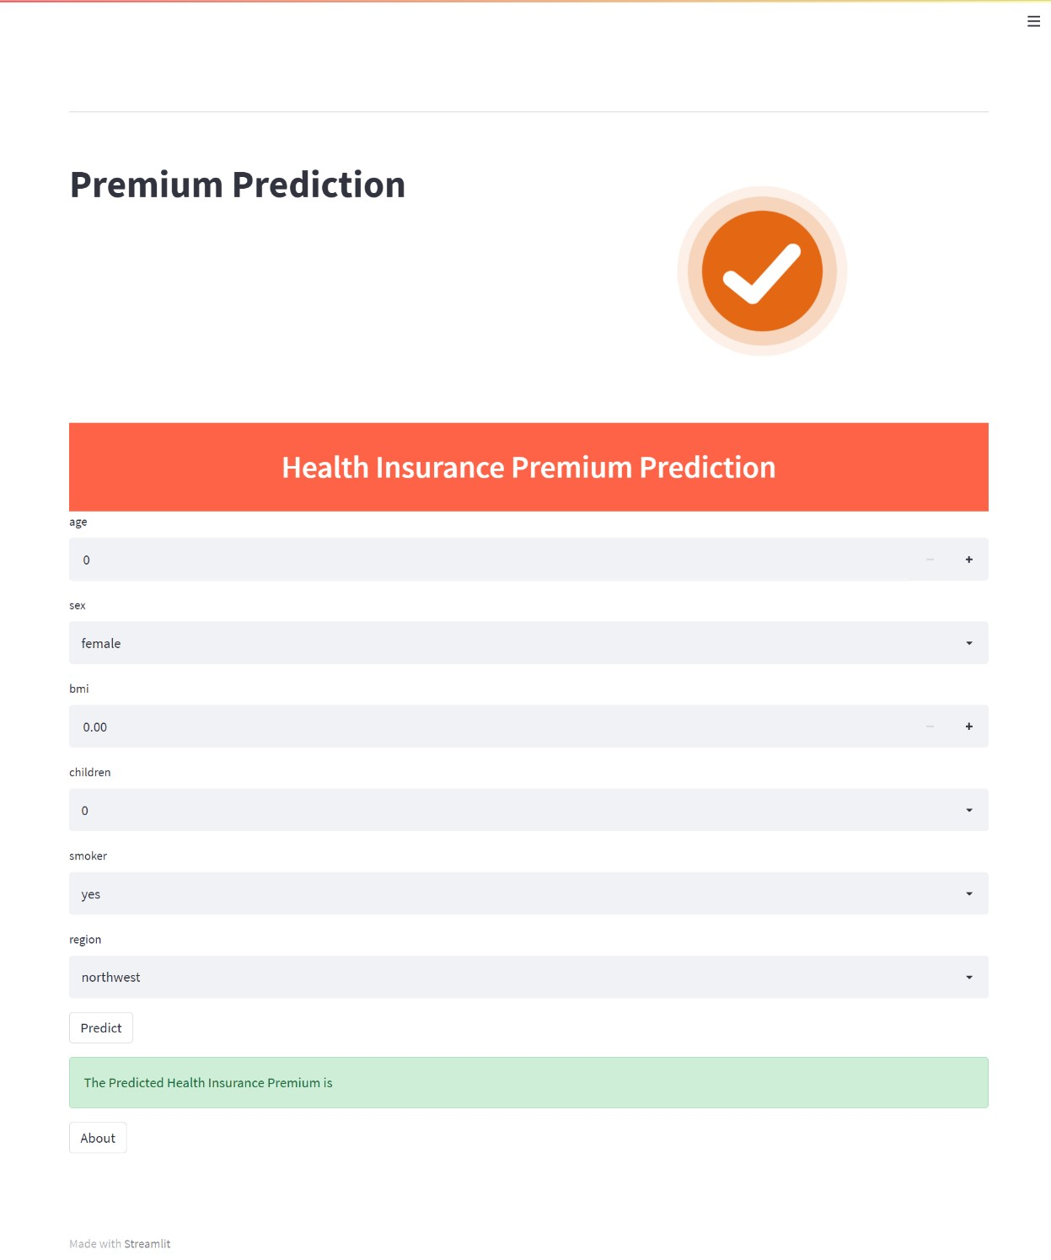

After filling the above information webpage looks like:

